**Name- Tushar Chaudhary**

**Roll no. 2100290310152**

**Sec-C**

***EXPERIMENT NO:-3***

***OBJECTIVE***: Plot the pole-zero configurations in s-plane for the given transfer function.

*SOFTWARRE REQUIRED:-*MATLAB 2022

***THEORY***:

The pole-zero and transfer function representations of a system are tightly linked. For example consider the transfer function:

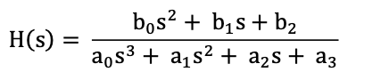

If we rewrite this in a standard form such that the highest order term of the numerator and denominator are unity.

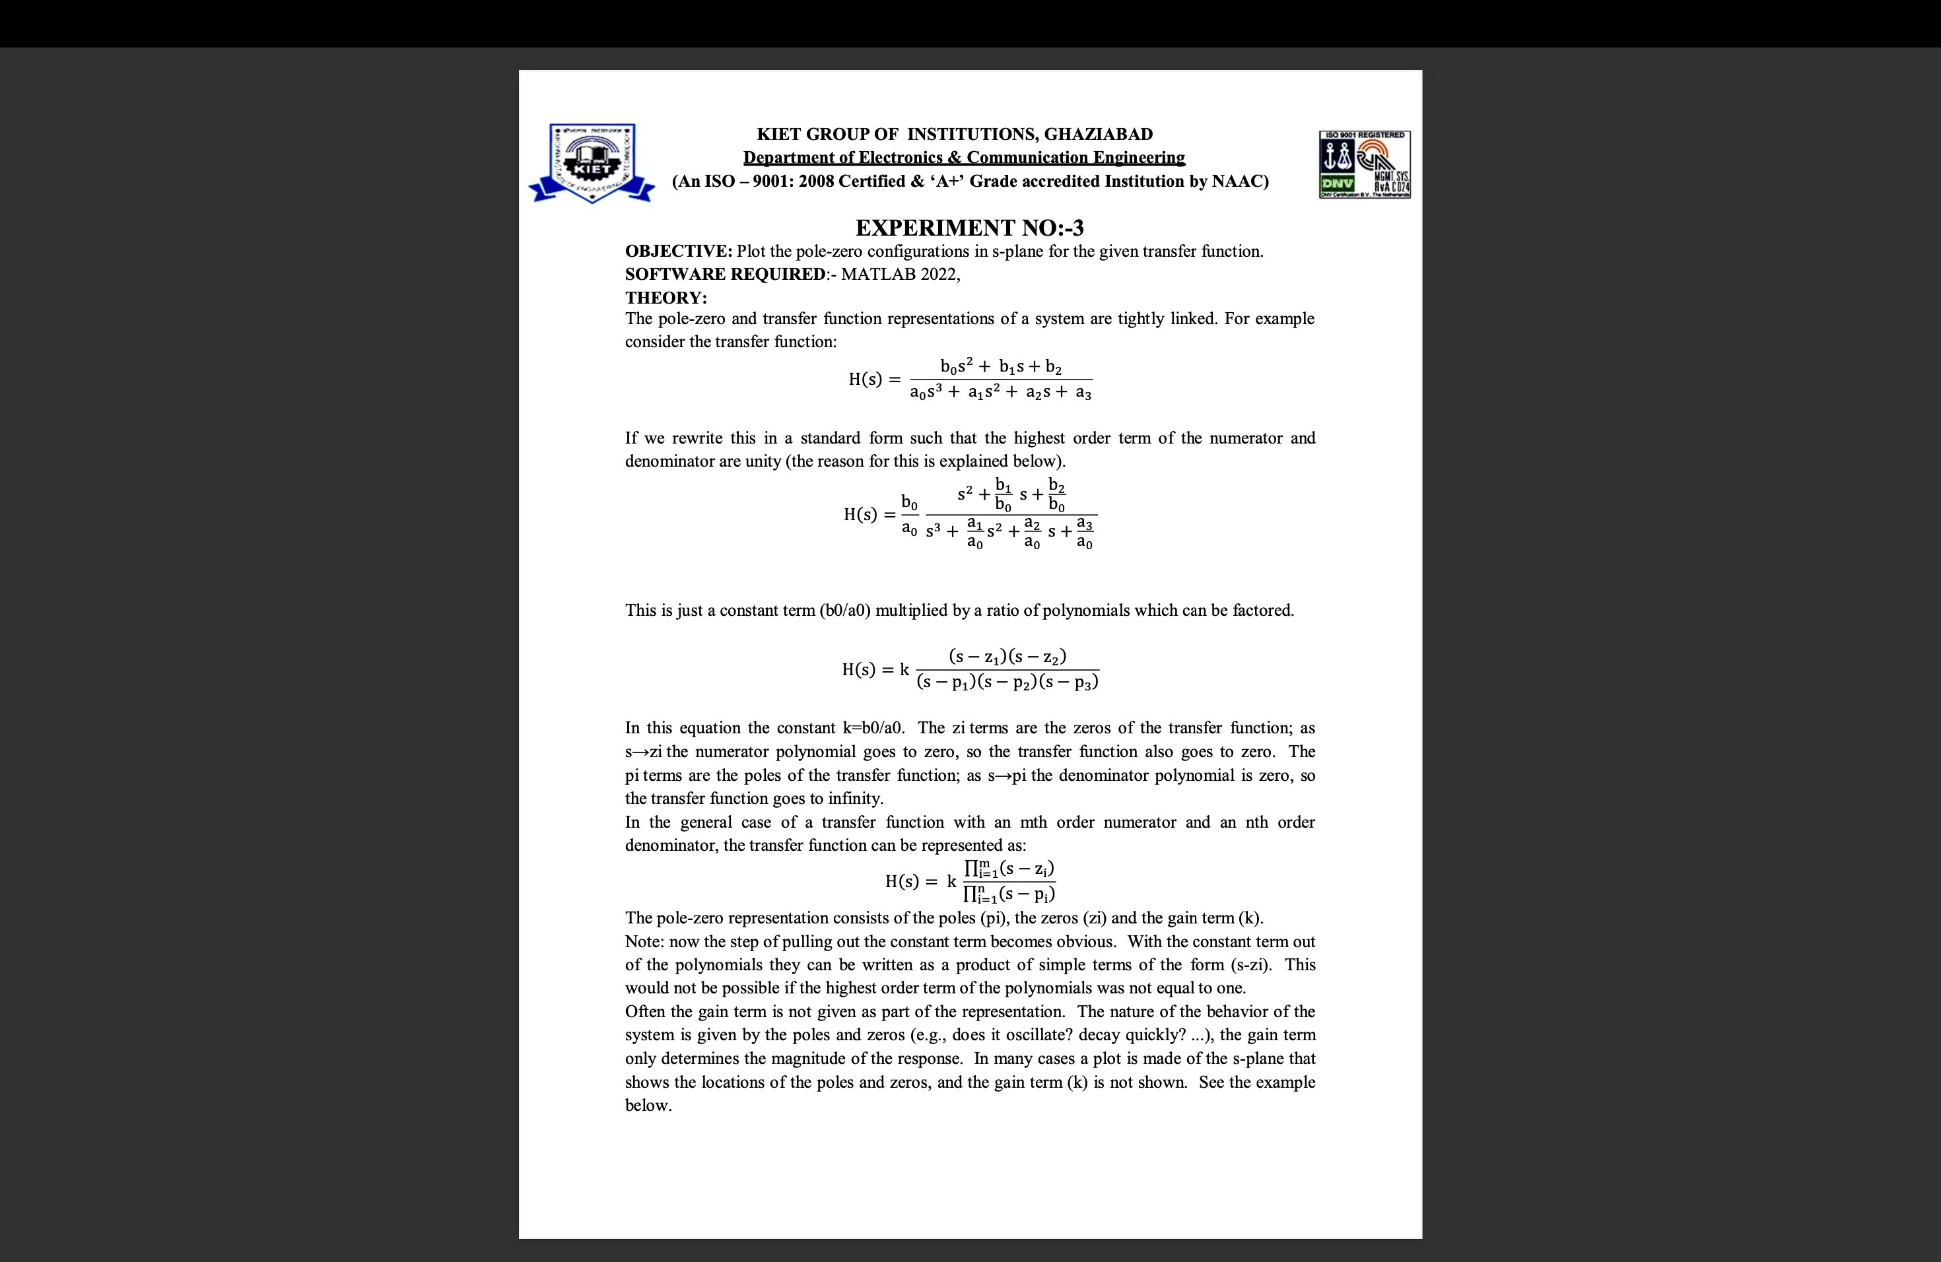

This is just a constant term (b0/a0) multiplied by a ratio of polynomials which can be factored.



In this equation the constant k=b0/a0. The zi terms are the zeros of the transfer function; as s→zi the numerator polynomial goes to zero, so the transfer function also goes to zero. The pi terms are the poles of the transfer function; as s→pi the denominator polynomial is zero, so the transfer function goes to infinity.

In the general case of a transfer function with an mth order numerator and an nth order denominator, the transfer function can be represented as:



The pole-zero representation consists of the poles (pi), the zeros (zi) and the gain term (k).

Example: Find the pole-zero representation of the system with the transfer function:

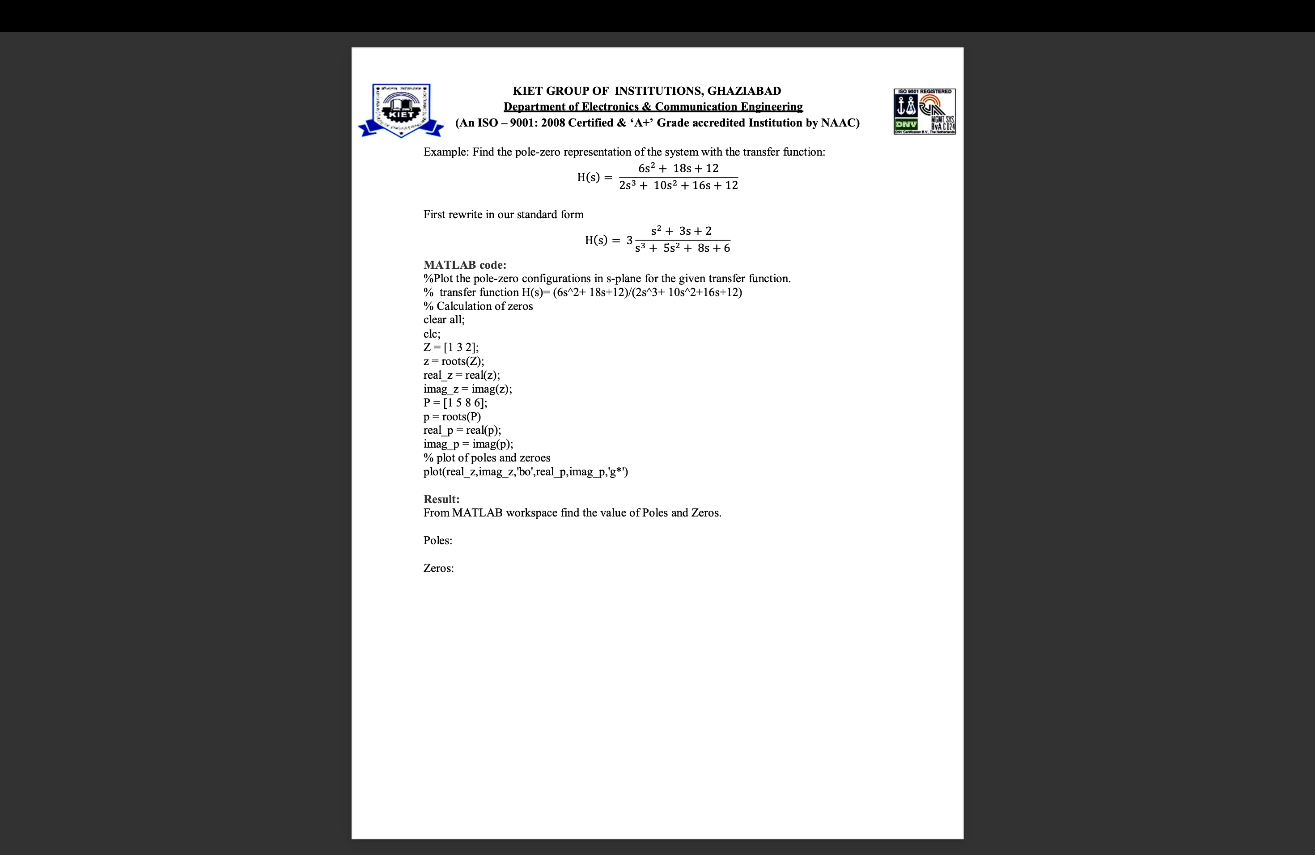

First rewrite in our standard form



***MATLAB code***:

clear all

clc

Z = [1 3 2]

z = roots(Z)

real_z = real(z)

imag_z = imag(z)

P = [1 5 8 6]

p = roots(P)

real_p = real(p)

imag_p = imag(p)

***Result***: 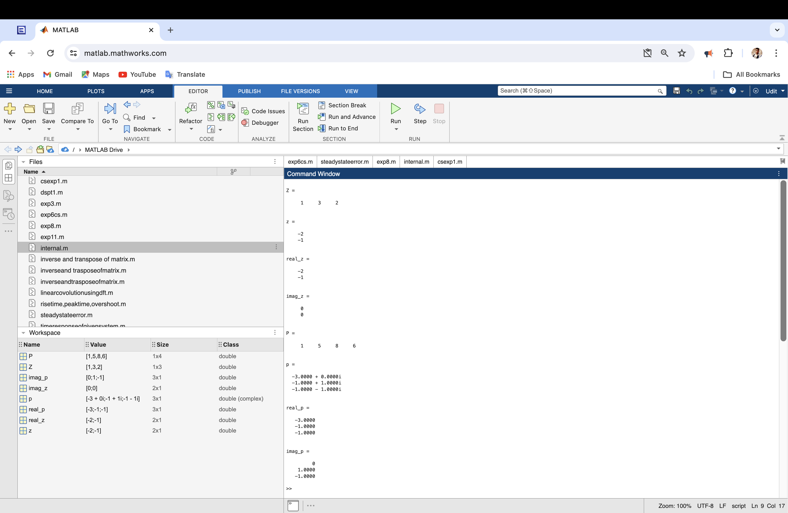

***Application:***

The applications of pole-zero configurations in the s-plane are primarily in control systems engineering and signal processing.

By analyzing the pole-zero locations, we can determine system stability, frequency response, and transient response characteristics.

This analysis helps in designing and optimizing systems to meet desired performance specifications.